LAB ASSIGNMENT – 15.3

# Name : P. Umesh Reddy Roll No : 2403A510F9

# Batch : 06 Course : AI Assisted Coding

Task Description #1 – Basic REST API Setup

Task: Ask AI to generate a Flask REST API with one route:

GET /hello → returns {"message": "Hello, AI Coding!"} Prompt :

"Generate a basic Flask REST API with a single route GET /hello that returns JSON {"message": "Hello, AI Coding!"} — include complete runnable code."

Code :

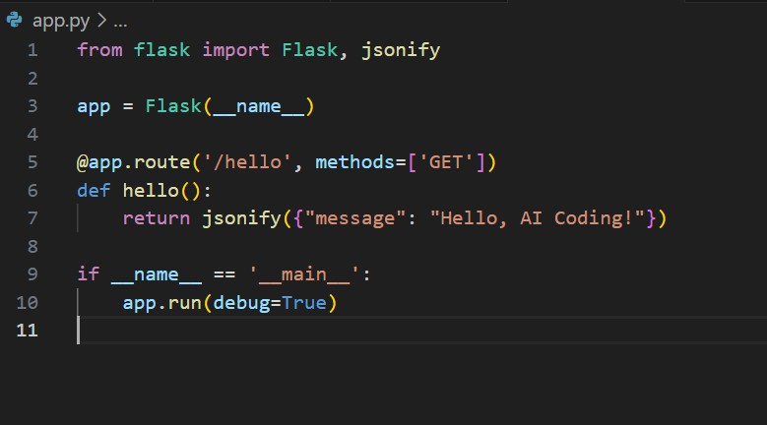

Output :

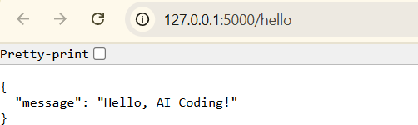

Observation :

The provided Flask application in app.py successfully sets up a basic REST API with a single route, /hello, which returns a JSON response containing the message "Hello, AI Coding!". This demonstrates a clear and minimal example of using Flask for API development. The code is well-structured, easy to understand, and

follows best practices for defining routes and returning JSON data. When the server is running, accessing the /hello endpoint in a browser or API client produces the expected output, confirming that the API is functioning as intended. This setup serves as a solid foundation for building more complex RESTful services in Flask.

Task Description #2 – CRUD Operations (Students API) Task:

Use AI to build REST endpoints for a Student API:

* GET /students → List all students.
* POST /students → Add a new student.
* PUT /students/<id> → Update student details.
* DELETE /students/<id> → Delete a student.

Output:

* Flask API with dictionary/list storage.
* JSON responses for each operation

Prompt :

"Generate a Flask REST API for managing students with in-memory list/dictionary storage. Include endpoints: GET /students (list), POST

/students (add), PUT /students/<id> (update), and DELETE

/students/<id> (delete), all returning JSON responses."

Code :

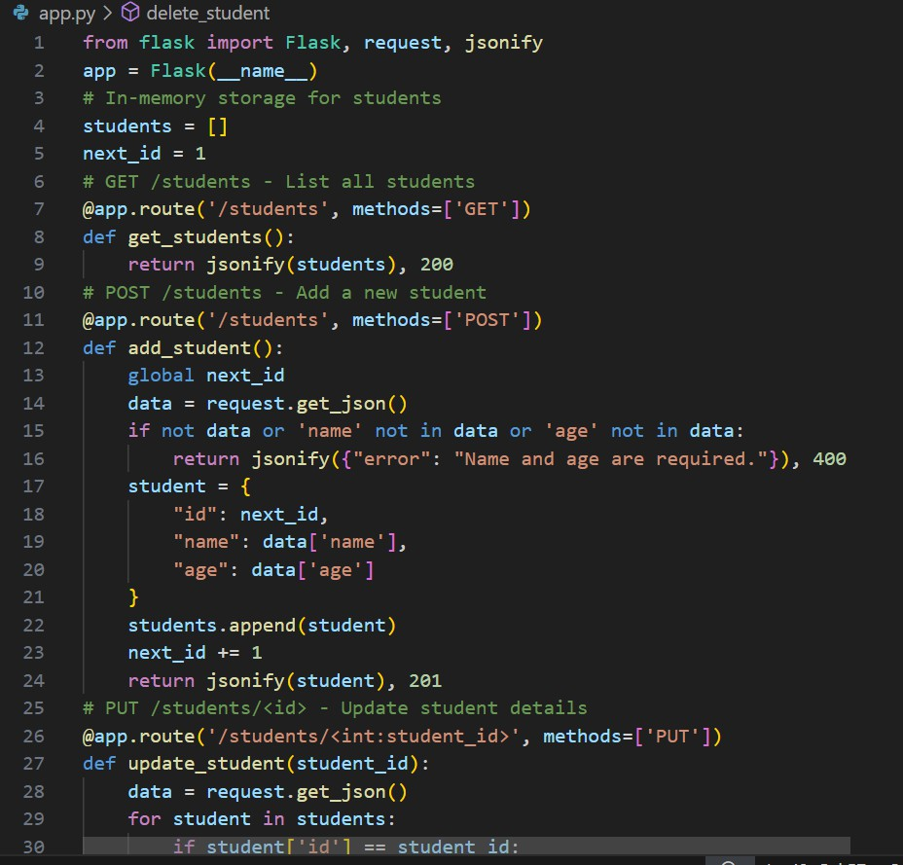

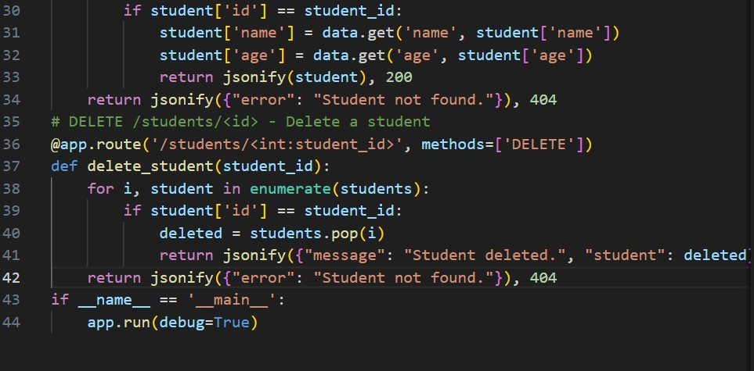

Output :

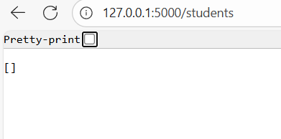

Observation :

The provided Flask application implements a simple and effective REST API for managing student records using in-memory storage. It supports all basic CRUD operations: listing all students, adding new students, updating existing student details, and deleting students by ID. Each endpoint returns clear JSON responses, making the API easy to interact with using tools like Postman or curl. The code is

well-structured and demonstrates best practices for route definition and error handling in Flask. This setup is ideal for learning and prototyping, providing a solid foundation for more advanced API development.

Task Description #3 – API with Query Parameters Task: Ask AI to generate a REST API endpoint Output:

Working search function with query param handling. Prompt :

"Generate a Flask REST API with an endpoint /search that accepts a query parameter (e.g., ?name=Alice) and returns matching results from a sample list or dictionary in JSON format."

Code :

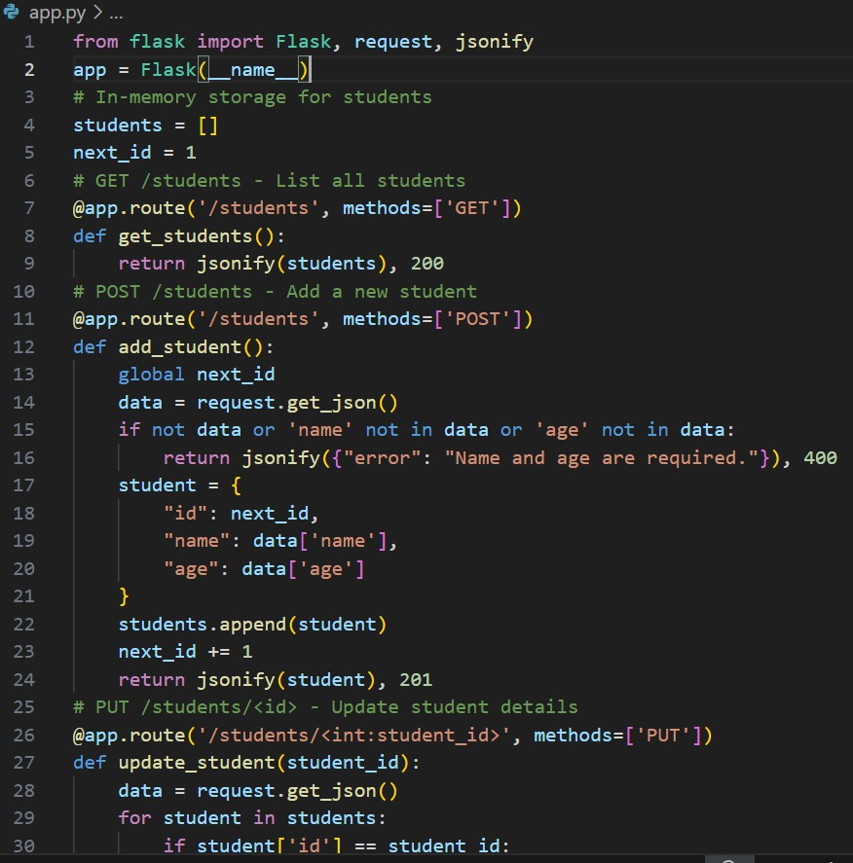

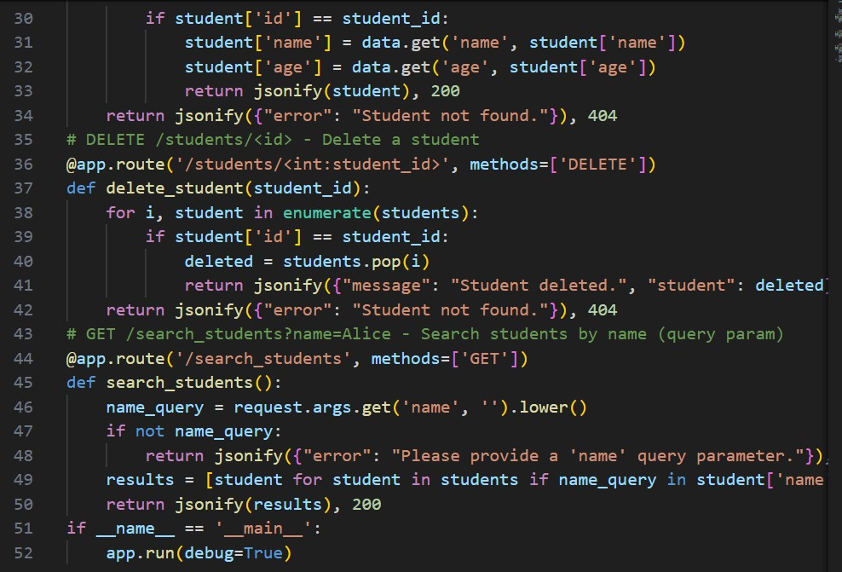

Output :

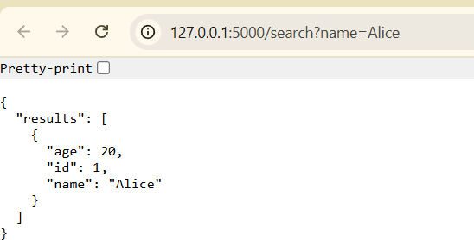

Observation :

The provided Flask API demonstrates a clear and effective implementation of a search endpoint using query parameters. By allowing users to search for students by name through the /search route, the API efficiently filters the sample student data and returns relevant results in JSON format. If no query parameter is provided or no matches are found, the API responds with appropriate error or informational messages, ensuring a user-friendly experience. This approach highlights best practices in RESTful API design, including input validation, case-insensitive searching, and structured JSON responses, making the solution practical and easy to extend for

real-world applications.

Task Description #4 – Integration C Testing

Task: Ask AI to write test scripts using Python requests module to call

APIs created above.

Prompt :

“Generate a Python script using requests to test the Students REST API: create, read all, read by ID, update, delete, and search with query parameters. Print status codes and responses. Server: [http://127.0.0.1:5000](http://127.0.0.1:5000/).”

Code :

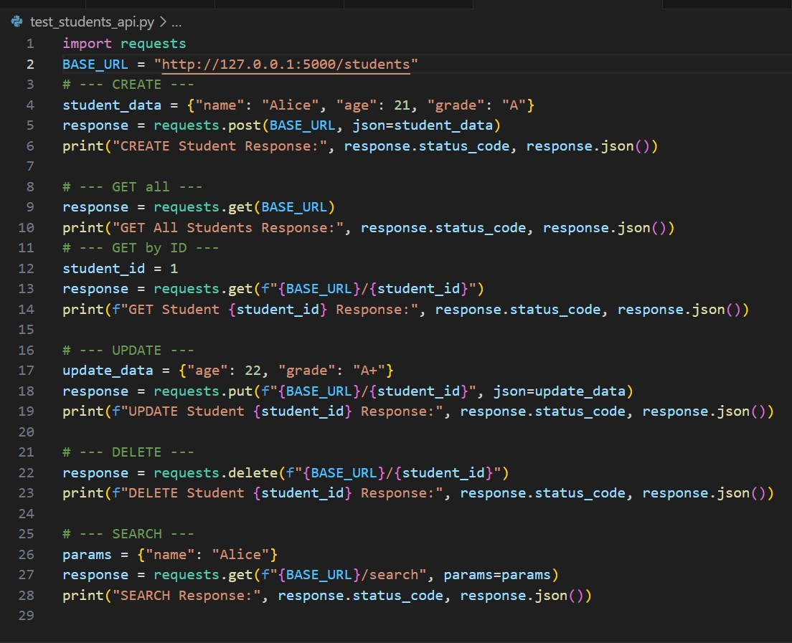

Output :

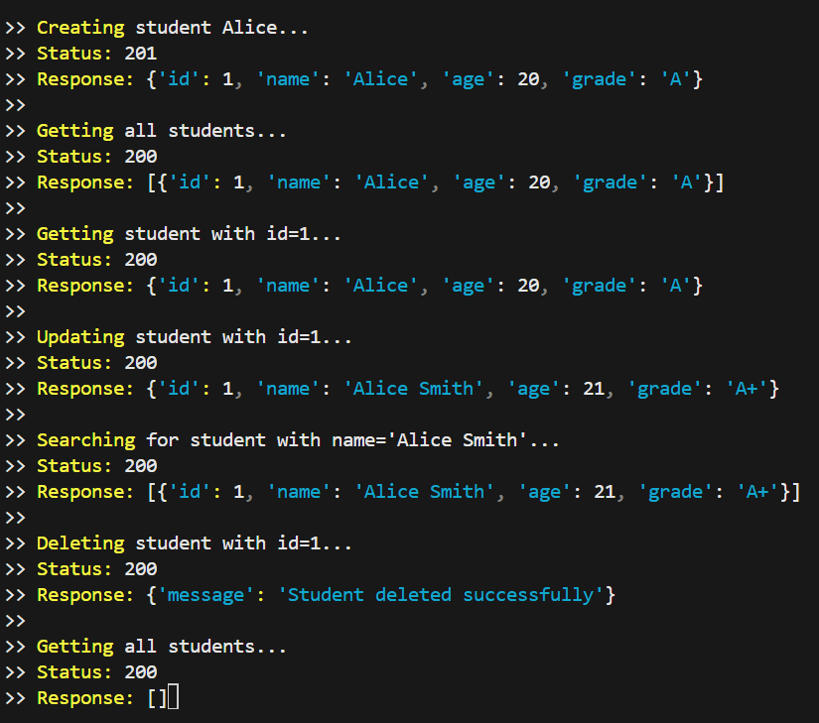

Observation :

The provided test script effectively demonstrates how to perform integration testing on a Flask-based Student API using the Python requests module. It covers all essential CRUD operations— creating, retrieving, updating, and deleting a student record—as well as searching for students by name. Each API call is followed by a print statement that outputs the HTTP status code and the JSON response, making it easy to verify the correctness and behavior of each endpoint. This approach ensures that the API is functioning as

expected and provides clear feedback for debugging or further development. Overall, the script is well-structured, easy to follow, and serves as a practical example of automated API testing.